DigiMesh update:

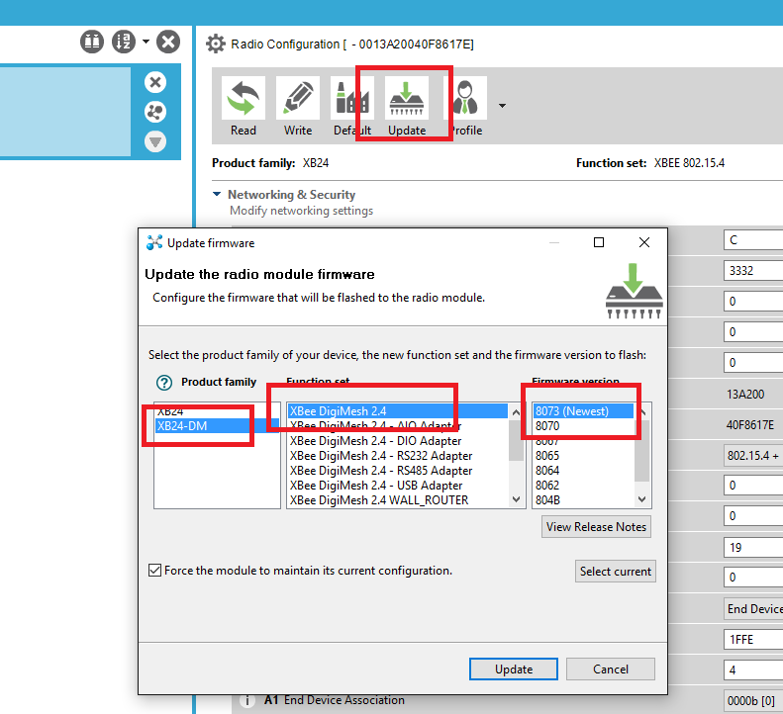

Write “XBee-DM_ArduinoProfile” profile with XCTU tools